AI-DRIVEN COMPLEX EMOTION RECOGNITION USING FACIAL EXPRESSION IMAGES
Scope and Limitations
Department of Computer Science and Engineering (Data Science), [COLLEGE NAME]
Batch A16 (CSDS-A) · Academic year [ACADEMIC YEAR]
Table 1: Project team
S.No. | Student name | Roll number
1 | B. Shirisha | 23K91A6730
2 | B. Ashrith | 23K91A6731
3 | B. Murali | 23K91A6724
4 | B. Goutham | 23K91A6727

Project guide: [GUIDE NAME]
Chapter and section numbers quoted in the text (for example Chapter 8 or Section 6.2) refer to the full project report, 17.Final Document. Figures and tables in this document are numbered from 1.

1. SCOPE

1.1 In scope
• Estimation of seven basic and eleven compound emotion scores for the largest face in a single still image (JPEG or PNG), returned as 18 independent sigmoid probabilities with a dominant label.
• Haar-cascade face detection, 64x64 grayscale preprocessing and a four-block CNN running on the CPU.
• Offline training of a 7-class backbone, a conditional GAN on 2,800 faces and a final multi-label classifier on 28,709 real plus 2,200 synthetic faces (FER2013).
• User accounts with JWT tokens, per-user analysis history with face thumbnails, and anonymous analysis through the API.
• A Next.js console (landing, register, login, analyse, history) and a FastAPI service with eight endpoints and a health check.
• Evaluation on the FER2013 test set, a seeded real-only control, a synthetic hold-out, API latency and abuse probes, as reported in Chapter 8.

1.2 Out of scope
• Identity-preserving generation: the code has no identity encoder, so objective 1 of the batch is not implemented as in the base paper.
• Real compound-emotion ground truth (RAF-DB compound, C-EXPR-DB, CFEE): none was available, so compound outputs cannot be scored on real faces.
• Video, tracking, several faces per image, colour or 3-D input, audio or text cues.
• Clinical, safety or hiring decisions: the model is not validated for any such use and its accuracy is 58 % on seven classes.
• Cloud deployment, multi-tenant operation, rate limiting, token revocation or password reset.
• Demographic fairness analysis and consent management for stored images (only a cropped face thumbnail is stored).

1.3 Deployment boundary
Table 2: Where the system is meant to run
Item | Boundary
Host | One Windows PC, Python 3.11, CPU only (measured on an Intel Core i5-12500 class machine, 15.7 GB RAM, shared with other jobs)
Servers | FastAPI on port 8000 by default (8116 in this documentation run), Next.js on 3000
Storage | One SQLite file, three checkpoint files, a folder of JPEG thumbnails
Network | No outbound calls at run time; CORS admits localhost:3000 and 127.0.0.1:3000
Users | A handful of accounts on one machine

2. ASSUMPTIONS
The design and the measurements rest on the following assumptions. Where an assumption could not be checked it is marked.
• FER2013 labels are correct enough to score basic emotions against, although the dataset is known to contain label noise (not checked here).
• A compound expression can be approximated by conditioning a generator on its two basic emotions at 0.5 each, as the base paper does with two active label bits. This assumption failed in practice: the generator does not follow its condition.
• A synthetic face should carry three positive targets: its two basic emotions and the compound. The classifier therefore treats the labels as independent sigmoid outputs.
• The largest Haar detection is the face of interest (an assumption for photos with several people; untested).
• A 64x64 grayscale crop is enough information for seven basic emotions at the accuracy reported; no higher resolution was tried.
• The test PC (shared CPU, 15.7 GB) represents a modest user machine; latency figures are upper bounds because other jobs kept the CPU busy.
• Uploaded images are not stored; only the cropped grayscale face of a signed-in user's analysis is kept as a thumbnail.

3. LIMITATIONS
Each limitation below was found while building or measuring the system, and each is stated with the number that shows it.
1. No identity preservation and a weak generator. The code has no encoder and no identity loss. The conditional GAN was trained for 10 epochs on 2,800 faces and does not obey its condition (15.0 % of one-hot conditions recognised, chance 14.3 %); its faces are blurry (Fréchet distance 171.0 against 14.5 for real faces).
2. Compound emotions have no real ground truth. FER2013 has only basic labels, so the 11 compound outputs were never scored on real faces. On real faces they stay near zero (mean maximum 0.00019); on synthetic faces they sit at chance (ROC-AUC 0.497).
3. Synthetic labels are assumptions. A synthetic face is labelled with both condition emotions and the compound. Because the generator ignores its condition, many of those labels are wrong, which may explain why the head cannot separate the classes.
4. Small, noisy, imbalanced training data. FER2013 is 48x48 grayscale with known label noise; disgust has 436 training images (1.5 %) and a recall of 18.9 %. The test set also served as the per-epoch validation printout; no checkpoint was selected on it.
5. Short training on a CPU. Every model was trained for five or ten epochs on a shared CPU (about two minutes per epoch). No hyper-parameter search, augmentation or learning-rate schedule was tried, and the baseline reaches only 50.56 %.
6. Training and serving framing differ. Training faces are aligned 48x48 FER crops; serving uses a Haar crop of a photograph. Detection finds none of the native 48-pixel faces and 56.5 % after upscaling, and accuracy on detected faces drops from 66.2 % to 55.8 %.
7. One face, grayscale, still images. Only the largest detected face is analysed; there is no tracking, colour, video or multi-face handling. The webcam tab was not exercised in the headless captures.
8. The decision rule favours basic labels. dominant is the argmax over all 18 sigmoid outputs; with compound outputs near zero the rule always returns a basic emotion, and the unused threshold argument of analyze_image_bytes has no effect.
9. Application defects. A hard reload of /app redirects to the login page in development mode; the result thumbnail is a relative URL that resolves against the UI origin and shows a broken image; /app/history/[id] exists but no link reaches it; /api/analyze answers 200 where API_CONTRACT.md says 422, and an undecodable file produces HTTP 500; the e-mail address is not validated.
10. Local, single-user deployment. The service runs on one machine with SQLite, CORS for localhost:3000 only, a development secret key unless MOSAIC_SECRET_KEY is set, no rate limiting and no .env.example or start scripts.
The next two figures show the limitation that matters most: the generator's failure to follow its condition and the chance-level compound ranking on synthetic faces.
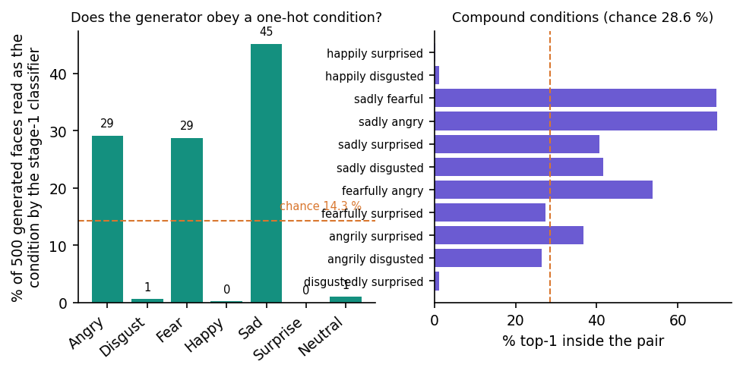
Figure 1: Conditional fidelity of the cEmoGAN: share of generated faces read as the requested emotion (left) and as a member of the requested compound pair (right).
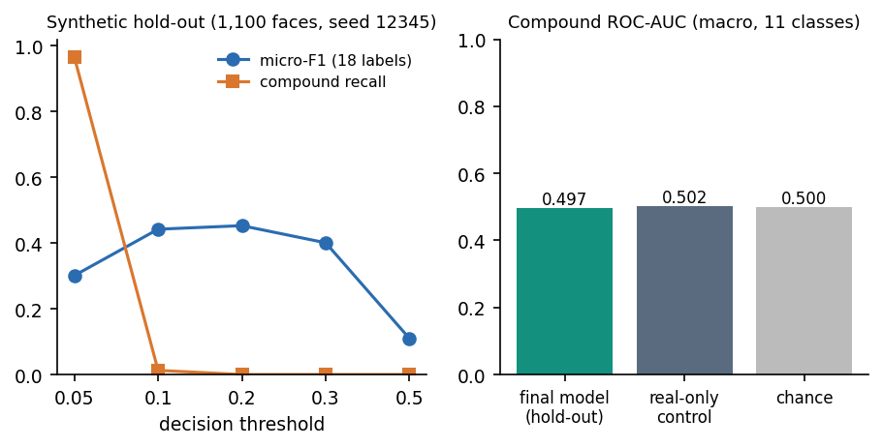
Figure 2: Synthetic hold-out: F1 and compound recall by decision threshold, and compound ROC-AUC against chance.

4. WHAT WAS NOT MEASURED
Gaps are listed instead of being filled with plausible numbers. Each row says why the quantity is missing.
Table 3: Quantities that were not measured
Quantity | Reason
Identity preservation of generated faces | The code has no identity encoder; the base paper's face-recognition similarity test was not run.
Inception score, Fréchet inception distance and BRISQUE as in the base paper | Only a Fréchet distance in the stage-1 CNN's feature space was computed; it is not comparable with published FID.
Recognition of compound emotions on real faces | No real compound ground truth was available (RAF-DB compound and C-EXPR-DB need a licence).
Action-unit analysis of the generated faces | The base paper's check with an AU recogniser was not run.
Colour, pose, occlusion and demographic robustness | FER2013 is grayscale and frontal-ish; no subgroup or fairness audit was done.
Webcam capture path | The captures are headless; the webcam tab was opened but no camera frame was analysed.
Multiple faces in one image | Only the largest face is analysed; the case was not tested.
Behaviour on GPU or at scale | Everything ran on a shared CPU; throughput under concurrent users was not measured.
Usability with real users | No user study; the console was exercised by the team only.
Security review of the API | Malformed-input probes and tests only; no penetration test, rate limiting or token revocation.

